

# Atlas of Mystara

First steps

Computer Science and Engineering

2022-2023

**Author:**  
**Afonso de Cintra Vinhas Costa Leitão (96722)**

**afonso.leitao@tecnico.ulisboa.pt**

****Index****

Table of Contents

**Atlas of Mystara1**

**List of Hexmap examples**4

**HEXTML**4

**Molotov Cockatiel Hex Map Maker**5

**Worldographer / Hexographer II**5

**HexSim**6

List of Papers7

****1. List of Hex map examples****

**Objective: list 3 or 4 examples of hex map usage (editor, tool, web map) and a brief description of at least one of them.**

1. **HEXTML (**<https://hextml.playest.net/>**)** 
   * **HEXTML is a hex map editor specifically made with the purpose of DnD campaigns. It has many interesting features that would be very useful to a DM such as connecting maps via a sub maps menu, adding secret notes only visible to the DM and allowing for collaboration both for help building the map itself and for other players to join in and play the campaign directly on the website.**
   * **As for editing of the hex maps it has tiles of various colours each with different names, allowing users to add their own tile set if they choose to do so. It has a stamp system that lets you stamp out tiles with other tiles and/or symbols. It also allows users to override the background colours of the hexes by using the colour menu. It’s possible to manually add rivers, roads and borders to all hexes. The map editor also has a fog of war feature that can hide certain tiles from the players until the DM desires to do so.**
   * **The hexes themselves can have information in them. They each have three menus where it’s possible to input text: Text (used for hovering text on the tile), Secret Notes (only visible to the DM) and Player’s Notes (visible to both the player and the DM)**
   * **The map also has the option of using three different grid shapes. Two of them are hexagon grids with the hexagons aligned in different ways and the last one is a square grid.**
   * **There is a feature to export the map to an image, I’ve made a very simple map which covers most of the features of this editor (presented below) and found out the map-to-image is a bit flawed as it cuts the right outer edge of the map. The exported map doesn’t include the borders, the rivers and the roads I’ve added and the hexes have a thicker border than in the editor.**

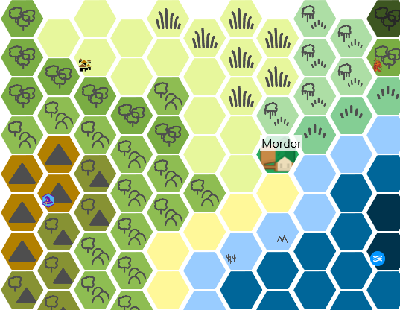

1. **Molotov Cockatiel Hex Map Maker (**<https://molotovcockatiel.com/hex-map-maker/>**)**
   * **This one has a simpler approach to hex map making. It asks the user to prompt out the map size and it generates it for him letting the user paint over the generated map with solid colour only tiles.**
   * **What I found interesting about this one was the fact that it exports the map to SVG and to an “array of hexes”. This sadly turned out to be a list of lists containing numbers from one to eight which were associated to each of the possible hexes the editor used (with one being the clear tile and eight being the custom tile), meaning there was no difference between two different custom tiles.**
   * **The tool also pointed out that “**Pointed-top hexes take up more vertical room, so flat top generally works better.” Which might be important to note.
2. **Worldographer / Hexographer II (**<https://worldographer.com/>**)**
   * **I tested Worldographer on a free version, this one is a full-fledged application with a lot more features and detail than the others.**
   * **It has the feature of generating its own maps with options for generating rivers, roads, nations and more. It’s possible to fully customise any given tile with numerous options for transparency, texture, colour, etc.**
   * **In this editor, hexes have two numbers associated with them, one for the row and the other for the column, making it easy to locate a hex by its coordinates.**
   * 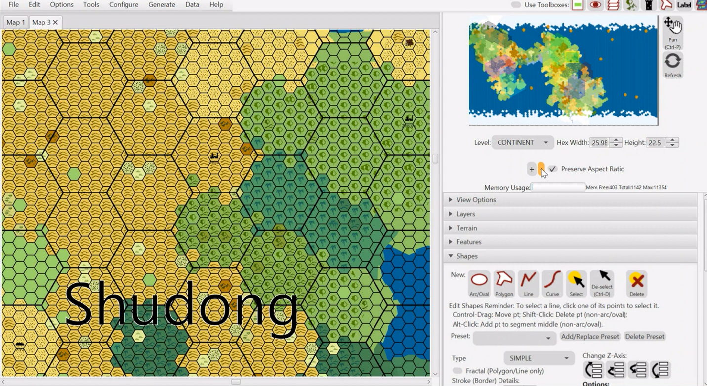**This editor solved a problem present in bigger maps. How do you zoom out? The hexes are too small on maps of bigger sizes; this makes them hard to see when looking at a whole continent for example. Worldographer solves this by creating bigger hexes made up of the smaller hexes.**
   * **As for zooming in, Worldographer has (similarly to the first example) map links that increase the level of detail. You traverse to the maps via a menu called info that appears on the right side of the screen when clicking a tile. These maps, often used as town or village maps. These aren’t exactly made form premade tile sets but are essentially a picture with a uniform hex grid on top.**

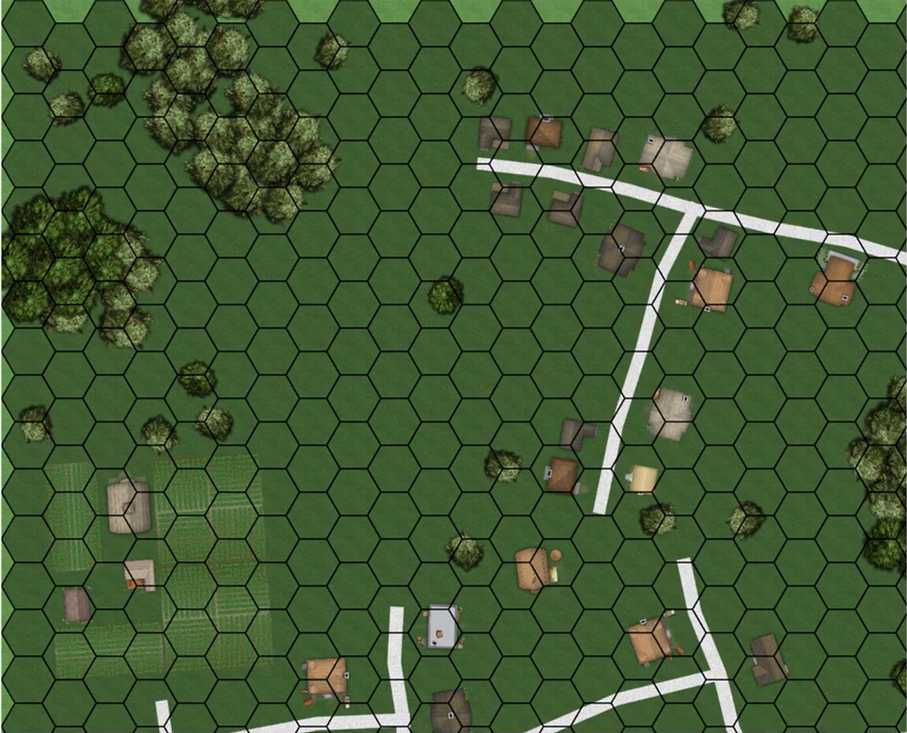

1. **HexSim (**<https://www.hexsim.net/home>**)**
   * **HexSim simulates the behaviour of plant and animal life on a Hex map. The map’s layout is static but its content changes every tick to simulate species’ interactions.**

****2. List of Papers****

**Objective: list 4 or 5 papers related to the project**

1. Ali Mahdavi-Amiri, Erika Harrison & Faramarz Samavati (2015) Hexagonal connectivity maps for Digital Earth, International Journal of Digital Earth, 8:9, 750-769, DOI: <https://doi.org/10.1080/17538947.2014.927597>
   * Here six types of hexagonal refinement are mentioned. 1-to-3, 1-to-4, and 1-to-7 refinement in both their centroid-aligned (c-refinements) and vertex-aligned (v-refinements) variants. These refinement approaches could be used to zoom in/zoom out of a hex map.

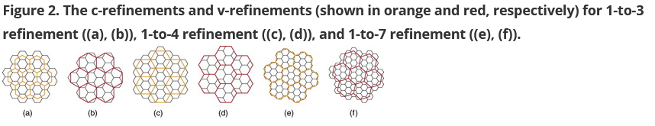

1. Martyniuk, Taras. "Implementing Hexmap Generation Framework using Cube Coordinate System in Unity3D." (2021)
   * In this paper, different coordinate systems for hex grids are discussed. Two alternatives are proposed. The first one is similar to the system used in **Worldographer. Essentially, each hex has two coordinates that represent the offset of that hex in relation to the edge of the grid. Meaning hex (1,3) would be on the second column of the forth row of the grid (since it starts at 0). The second approach uses cube coordinates to differentiate the hexes. With three axis (x, y, z) which are aligned with the three pairs of sides a hexagon has can also be used to map out the grid. The study concludes that The added axis of cube system allows for a natural and much easier transition to neighbouring hexes and simplifies algorithms.**

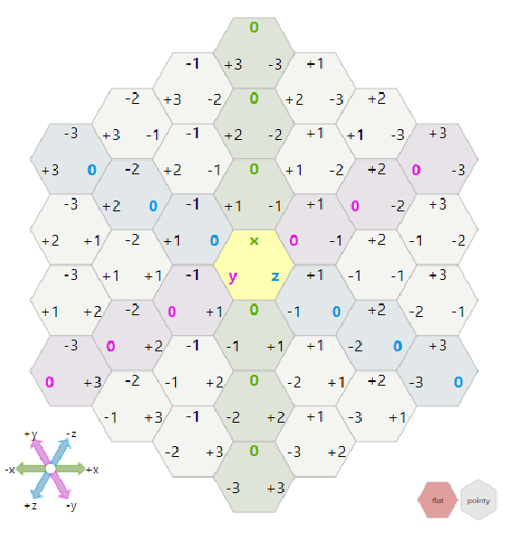

* Offset system is more straightforward and easier to reason and explain. Cube system, while having a more complex way of defining each hex, is more elegant and better fitted for hex grids, since it represents the laws (e.g directions and relative positioning) of hexagonal grids more naturally, which in turn simplifies most of the algorithms for operations defined on hexagonal grids.

1. Yao, X.; Yu, G.; Li, G.; Yan, S.; Zhao, L.; Zhu, D. HexTile: A Hexagonal DGGS-Based Map Tile Algorithm for Visualizing Big Remote Sensing Data in Spark. ISPRS Int. J. Geo-Inf. **2023**, 12, 89. <https://doi.org/10.3390/ijgi12030089>
2. Rummelt, N. Array Set Addressing: Enabling Efficient Hexagonally Sampled Image Processing. Ph.D. Thesis, Unversity of Florida, Gainesville, FL, USA, 2010

**More notes**  
  
Em suma: keep on looking!  
  
Quando começares a ter mais, verás que começam a surgir na tua cabeça relações entre trabalhos, famílias de abordages semelhantes. Isto dar-te-á a forma de organizar a sequência deles no documento, eventuais subsecções (não tem que ser papers vs sistemas)  
  
Tenta ver coisas sobre:  
  
- World-covering hexes. A projeção geográfica é importante. Se fosse mercator, os hexes tinham que começar a distorcer à medida que nos aproximamos dos polos. No AoM o Thorf já resolveu isso, mas não seria mau ter essa explicação no documento.  
  
- Hexmaps at different scales  
  
- Se encontrares alguns artigos/livros/posts sobre "a história dos hexmaps" não serão provavelmente para o capítulo do trabalho relacionado, mas ficam bem na Intro!  
  
  
Bom trabalho!!  
D.

**Further research**

42 Rolls of duck tape:

* **This is a blog created by Lance Duncan, a** Geography student at the University of California Northridge **in 2017 and it details his work on his capstone project. This project’s goal was to** build a web map and analyse the benefits and drawbacks of such an application, specifically in regards to fantasy and rpg maps.
* This project will focus on the Grand Duchy of Karameikos in the fantasy world of Mystara. While limited, Duncan’s work can be seen as a proof of concept for our Atlas of Mystara. The country covers an area of approximately 22,260 square miles, an area slightly larger than modern Croatia. Mystara is 6,190 miles in diameter (3,095 radius). The total surface area of the planet's outer world, minus the polar openings, is just over 105 million square miles. 60% of which are covered by water meaning our project would have about 4716 times the magnitude of Duncan’s project.
* The webmap has a couple of limitations besides the area it covers. Firstly, it’s very slow (the web page takes about 40 seconds to load), unresponsive and the panning is not seamless. The perspective is warped and the map has some visual bugs.

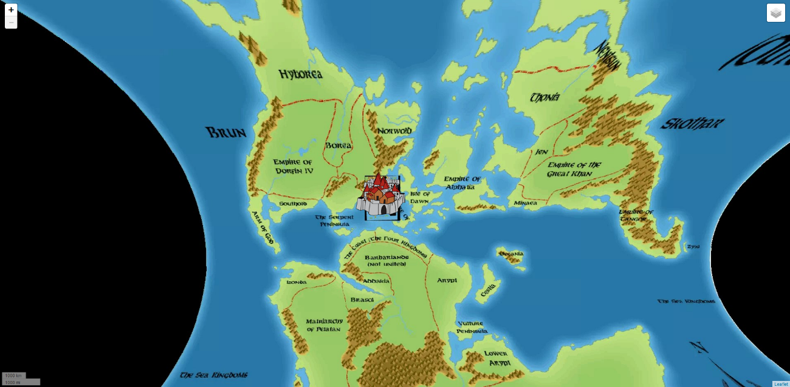

* Unfortunately, this solution doesn’t solve some of our main concerns such as how to handle zoom. It’s also important to note that in the hex map, the hexes themselves aren’t interactive. Instead, Duncan made it so that the icons he placed on top of the map were clickable and the rest of the map is simply a very big bitmap

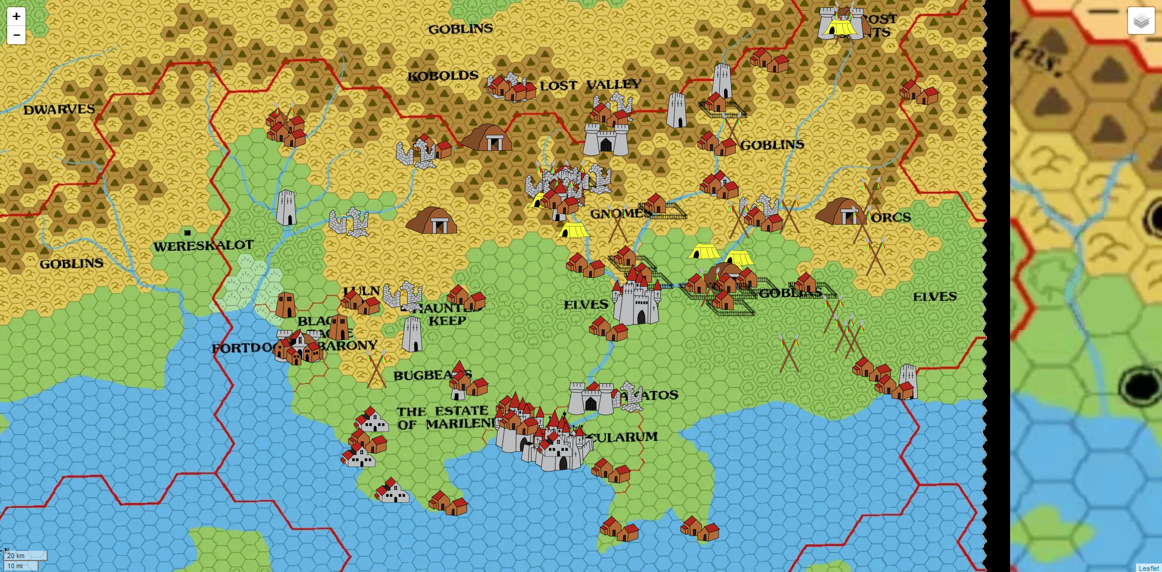

**Thorf’s Hex Mapping Tools:**

* **Thorfinn made a set of tools he often used while creating maps available including tile sets and guides on how to create maps. It's a valuable resource to use as a reference to identify hexes in his maps since the tile sets can be used to identify what kinds of hexes we are dealing with**
* **It might be useful to have a way for users to add their own custom tile sets to our existing database in order to help us validate and understand what kind of maps are being uploaded to our system.**

**Mkhexgrid:**

* **mkhexgrid is an open-source software for generating hex maps. It's written in C++ and has a lot of customization tools to work with. It can be useful to explore the necessities of hexagon tile's attributes and methods when inserted in a hex map.** Users can provide input through a specification file or command-line options to control the grid's characteristics, such as size, colors, and output format. The program is designed to be flexible and configurable for different grid generation needs. It includes functions for drawing grids in different output formats (PNG, PS, SVG) and parsing configuration options.

**What the Hex? (a brief history of the hex):**

* **Kevin Flerlage, of the Flerlage Twins composed a document regarding the usefulness and history of hex maps as well as why to use them as opposed to a standard choropleth map, which is** a thematic map that is used to represent statistical data using the color mapping symbology technique. This focuses on the history of the technique’s use in Tableau, which is a software for interactive data visualization. But it’s easy to see the similarities to the evolution it might have happened over the years in the context of board games.
* The hex map has been a favourite for game designers since 1961, when Charles S. Roberts of the Avalon Hill game company published the second edition of Gettysburg with a hex map. The hex grid is a distinguishing feature of the games from many wargame publishers, and a few other games (such as The Settlers of Catan).
* The hex map has also been popular for role-playing game wilderness maps. They were used in the Dungeons & Dragons boxed sets of the 1980s and related TSR products. GDW also used a hex grid map in mapping space for their science-fiction RPG Traveller.

**Advantages and disadvantages of Hexmaps:**

There are three main advantages to overland mapping with a hex map, as I see it:

* Easy to judge distance due to the built in scale
* Easy to judge density of points of interest, also due to the built in scale
* Easy to scale the map up or down and put things roughly where they need to be

In board games were players have access to maps like these, it’s common to reference directions using cardinal direction (N, S, E, W) and this collides with the idea of hex maps.

On a hex map, southwest isn’t really southwest, or at least not without any adjustments. Instead it’s 30 degrees south of west, which is about 15 degrees off (or 60 degrees south, which is off 15 degrees the other way). This can have great impacts on a player’s experience. For instance, f they travel a week north, a week east, and then travel back southwest, they’re not actually going to get back to where they started. To work around this issue, it is common to mention the hexes themselves when moving; “I travel a hex east, then a hex northeast, then a hex north” rather than to pretend you don’t have access to the convenience of hexes on your map.

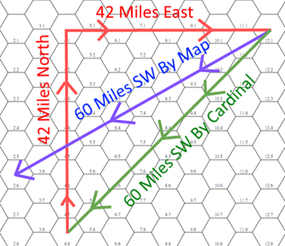

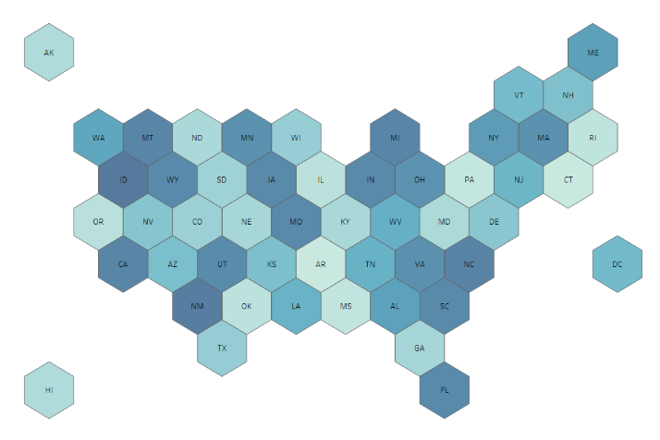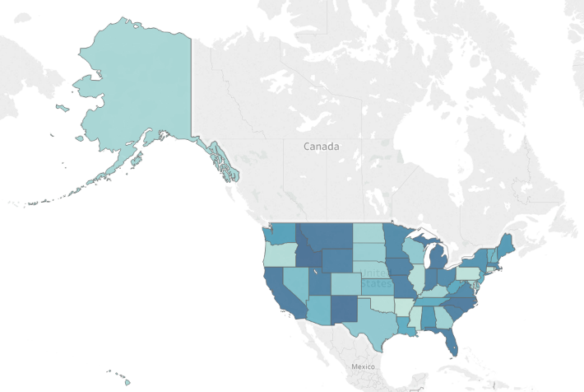

* In the **Flerlage Twins** post mentioned above, Kevin mentions the “Alaska Effect”. The Alaska Effect is where the lower 48 states are greatly minimized due to Alaska’s size on a map and its location far to the Northwest. Hex maps eliminate this issue as well because all states are equivalent in size and Alaska and Hawaii are brought in closer to the lower 48 states.

**Hex grids vs Square grids vs Triangle grids (**[**http://www-cs-students.stanford.edu/~amitp/game-programming/grids/**](http://www-cs-students.stanford.edu/~amitp/game-programming/grids/)**)**

Many war games use hexagonal grids instead of square grids. Squares share an edge with four neighbours but also touch another four neighbours at just one point. This often complicates movement along grids because diagonal movements are hard to weight properly with integer movement values. You either have four directions or eight directions with squares, but with hexagons, you have a compromise—six directions. Hexagons don’t touch any neighbour at only a point; they have a small perimeter-to-area ratio.

**Squares**

The most common grid is a square grid. It’s simple, easy to work with, and maps nicely onto a computer screen. Square grids are the most common grids used in games, primarily because they are easy to use. Locations can use the familiar Cartesian coordinates (x, y) and the axes are orthogonal. The square coordinate system is the same even if your map squares are angled on screen in an isometric or axonometric projection.

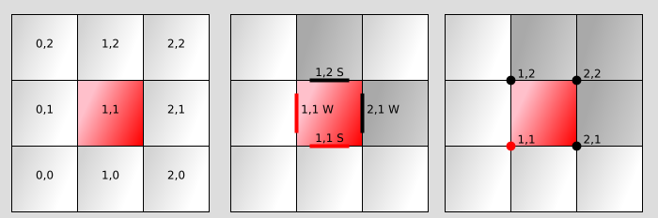

Square grid coordinate systems: faces, edges, vertices

**Hexagons**

Hexagons have been used in some board and computer games because they offer less distortion of distances than square grids. This is in part because each hexagon has more non-diagonal neighbors than a square. (Diagonals distort grid distances.)

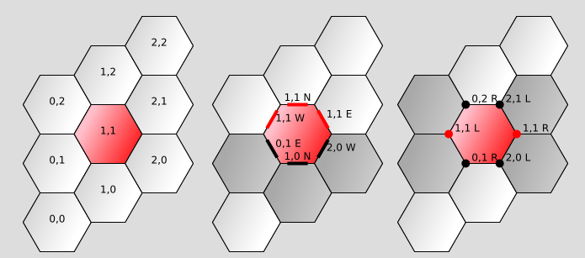

Hexagon grid coordinate systems: faces, edges, vertices

**Triangles**

Triangles are common in 3d graphics but are rarely used for game maps. A big disadvantage of triangle maps, aside from unfamiliarity, is the large perimeter and small area (the opposite of a hexagon). The small area means it’s harder to place game pieces completely within a single space on the map.

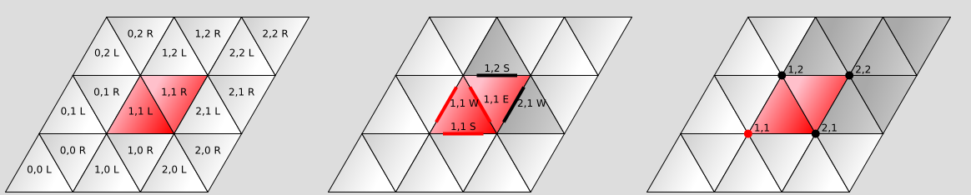

Triangle grid coordinate systems: faces, edges, vertices

**In Praise of the 6 Mile Hex**

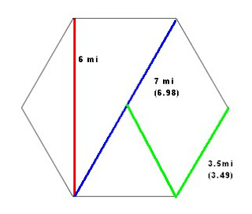

**Navigation.** Estimating a party's route through a 6-mile hex is a lot easier than any other hex. No other hex size breaks down as cleanly as a 6-mile hex. Its six miles from face to face. Vertex to opposite vertex is 7 miles. From the centre to any face is 3 miles (half of 6). From the centre to any vertex is 3.5 miles. From a navigation standpoint, any route through the hex in general is covered.

**Sub hexes.** The 6-mile hex can break down into half mile sub hexes. That is 12 hexes across. If there’s an important element in a hex, it is good to know where in the hex it is. Thus it makes sense to map out the hex in sub hexes. Each of these hexes can break down into sub hexes that are 1/24 of a mile across. 1/24th of a mile is a distance you can put on a battle mat. 5280ft/24 = 220 ft. 220 ft/5 = 44 battle mat squares. A Chessex Mondomat covers that area. Furthermore, if you are always using hexes that have 12 sub hexes across you only have to use one type of graph paper to keep track of all the projections. That is, the graph paper that you use for your sub hexes is the same as the graph paper you use for your sub hexes of sub hexes.

**Free-form maps?**

Free-form maps are maps that don’t use on a single repeating tile, but are more free-form. For example Risk, or [Metropolys](https://boardgamegeek.com/boardgame/25568/metropolys) have boards where at any given location the number of neighbours at that location can vary. That puts more emphasis on the landscape of the board. A tactic that works in one location needs to be adjusted for other locations. So when considering the question “squares, hexes or triangles” it’s important to consider whether you even need things to be tillable.

Here’s the map from Metropolis with the number of neighbours for each written down.

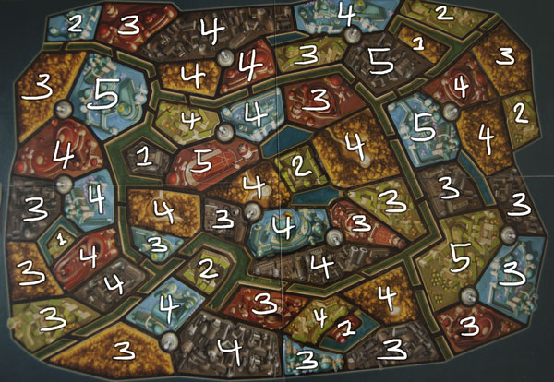

That’s 4 ones, 5 twos, 21 threes, 20 fours, and 5 fives, if you’re curious. Risk (not pictured) has 4 twos, 13 threes, 13 fours, 7 fives, 5 sixes. So, overall more connected than Metropolys.

Other:

A bunch of calculations, operations, conventions and implementation of a hex grid library (<https://www.redblobgames.com/grids/hexagons/> and <https://www.redblobgames.com/grids/hexagons/implementation.html>)

Example of a hex map tool in python (<https://www.youtube.com/watch?v=wZXW_nzJotc>)